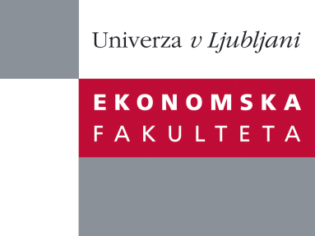
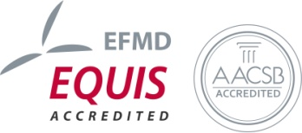

The Research Centre of the Faculty of Economics
cordially invites you to a research seminar
on Wednesday, 30th March 2016 at 1 p.m. in room P-216 at the
Faculty of Economics, University of Ljubljana

Author: Prof. Claude Obadia, Ph.d., ESCE (Ecole Supérieure du Commerce Extérieur), Paris

Coauthor: José Pla Barber, University of Valencia

Coauthor: Irena Vida, University of Ljubljana

will present the article:

"SMEs Export Success with International Relationships management"

»For exporting small and medium-sized enterprises (SMEs), the liability of smallness translates into higher operating costs, lower foreign-partner commitment, and higher attrition in their network of overseas distributors. Unsurprisingly, many SMEs discontinue their exporting efforts because of insufficient resources and disappointing results. This research investigates lower-resource-consuming processes that facilitate the sustainability of exporting activities for smaller firms. It focuses on the effectiveness of relational governance mechanisms, such as bilateral norms, that SMEs can use to manage their international alliances with overseas intermediaries. Using a longitudinal research design, the study shows that norms curb importer opportunism, help improve importer role performance, and increase the chances of survival of export ventures. In testing these relationships, the nature and the role of relational norms in cross-border business relationships had to be clarified first. The results of this study show that relational norms are heterogeneous and suggest that norms like continuity expectations play a leading role for structuring the ideology of a business dyad.«

You can register for the free seminar by phone (01) 58-92-490, or via e-mail: research.seminars@ef.uni-lj.si by Tuesday, 29th March 2016.

We look forward to seeing you!

