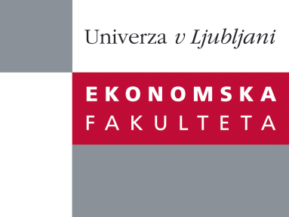


The Research Centre of the Faculty of Economics
cordially invites you to a research seminar
on Thursday, 24th March 2016 at 1 p.m. in room P-212 at the
Faculty of Economics, University of Ljubljana

Author: Dr. Dominik Schober, Competition and Regulation Research Group ZEW Centre for European Economic Research, MaCCI Mannheim Centre for Competition and Innovation

will present the article:

"Tax Incidence and Competition – The Case of Gasoline Retail Taxation"

“This paper explores how the intensity of competition in output markets affects the shifting of taxes to consumers. According to a popular view firms with market power are able to react to tax increases by passing on the burden to consumers while firms which face intense competition in output markets are unable to do so. In contrast, standard economic theory of tax shifting argues that the link between market power and tax incidence is ambiguous. We use data from the Austrian gasoline retail market to study this issue empirically. We find that the share of the tax shifted to consumers increases significantly with the market power of the suppliers. We find that the difference in the tax induced price increase between stations with the lowest and the highest degree of competition is equal to roughly 100 per cent of the overall tax increase. This difference persists in the medium term, i.e. for about one year, and vanishes after about two years returning back to normal margin differences between non-competitive and competitive markets. Furthermore, comparing tax and input price changes, we find that firms in more competitive markets shift the latter more quickly than the former. The may be due to salience effects. Since tax changes are more salient they may increase the price awareness of consumers around the time of the tax change.”

You can register for the free seminar by phone (01) 58-92-490, or via e-mail: research.seminars@ef.uni-lj.si by Wednesday, 23rd March 2016.
We look forward to seeing you!

