
The Research Centre of the Faculty of Economics
cordially invites you to a research seminar
on Tuesday, 13th December 2016
at 1 p.m. in room P-119
at the Faculty of Economics, University of Ljubljana

Author: Doctor of Philosophy Gayle Kerr, Queensland University of Technology, Business School Brisbane, Australia

will present the article:
"How consumers see media: A model of Paid, Earned and Owned Media"

“The purpose of this study is to investigate the attributes, consequences and values of paid, earned and owned media (POEM). In doing so, it employs Uses and Gratification Theory to chart the role of the active audience in optimizing media choice and maximizing user gratification.
Repertory Grid Analysis and Laddering explore the salient attributes, identify the values that consumers fulfill using POEM and build a Hierarchical Value Map (HVM). Also known as consumer decision maps, HMVs provide a standardized, easy-to-interpret, structurally-based representation of the consequences of media use. This consumer-centric model moves the discourse in IMC towards the under-researched typology of POEM. Although sensory information is already widely used in commercial advertising, only little is known about the effects of sensory information displayed on product packages in general and on packaged food in particular.”

You can register for the free seminar by phone (01) 58-92-490, or via e-mail: research.seminars@ef.uni-lj.si by Monday, 12th December 2016.

You can find all information regarding future research seminars on following link:
http://www.ef.uni-lj.si/raziskovanje/seminarji_in_konference

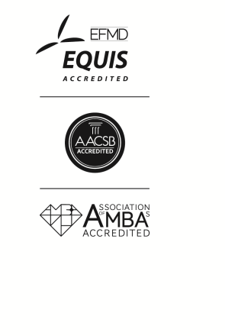
We look forward to seeing you!

