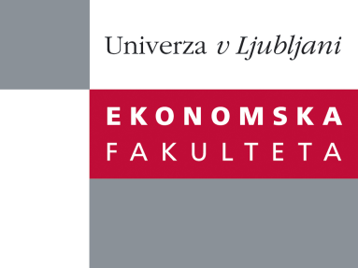
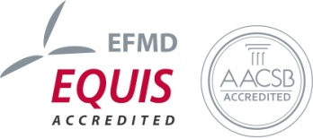

The Research Centre of the Faculty of Economics
cordially invites you to a research seminar
on Thursday, 19th May 2016 at 1 p.m. in room P-212 at the
Faculty of Economics, University of Ljubljana

Author: Ljubica Knežević Cvelbar, PhD, Associate Professor, The University of Ljubljana, Faculty of Economics

Coauthors: Sara Dolničar (UQ Business School, The University of Queensland Brisbane, Australia) and Bettina Grun (Department of Applied Statistics, Johannes Kepler Universität Linz)

will present the article:

"Reducing the environmental burden of hotels"

“Tourism harms the environment. It is acknowledged that tourism related activities are responsible for fife percent of the global CO2 emission and predictions are that this figure is going to more than double in the next 15 years. There are several ways how can tourism mitigate the negative environmental impacts. One way are governmental regulations. Those are reluctant to happen since supranational consensus is required bur hard to be achieved. Another possibility is use of the technology. Paris COP 21 climate change talk concluded that technological progress will be one of the most powerful tools in mitigating climate change in the future. The third approach is related to the market measures. Those are mainly focusing in green marketing and eco-friendly certifications. The forth option is in changing the human behaviour toward pro-environmental friendly. Although theoretically interesting, changing human behaviour is highly challenging in practice. Tourism context make this even harder since people are in their hedonic setting and are focus on their selfish goals – to let go and enjoy the holidays.
We developed and experimentally tested three interventions that have a potential of changing the tourist behaviour in tourism setting – specifically during the stay in a hotel. Our interventions are based on Equity and Stern theory. Experimental testing was done in the 4 star Bohinj Park ECO hotel in Slovenia. Results of our research will be presented at the research seminar.”

You can register for the free seminar by phone (01) 58-92-490, or via e-mail: research.seminars@ef.uni-lj.si by Wednesday, 18th May 2016.

You can find all information regarding future research seminars on following link:
http://www.ef.uni-lj.si/raziskovanje/seminarji_in_konference

We look forward to seeing you!

