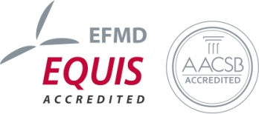
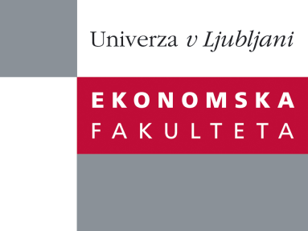

The Research Centre of the Faculty of Economics
cordially invites you to a research seminar
on Wednesday, 18th May 2016 at 1 p.m. in P-216 at the Faculty of Economics, University of Ljubljana

Author: Dr. Souvik Datta, Center of Economic Research (CER-ETH), Department of Management, Technology and Economics, ETH Zürich, Switzerland

Coauthors: Dr. Nina Boogen (Center of Economic Research (CER-ETH), ETH Zürich, Switzerland) and Prof. Dr. Massimo Filippini (ETH Zürich, Universit`a della Svizzera italiana)

will present the article:

"Demand-Side Management by Electric Utilities in Switzerland: Analyzing its Impact on Residential Electricity Demand"

“In this paper we use panel data from a survey conducted on 30 Swiss utilities to estimate the impact of demand-side management (DSM) activities on residential electricity demand using DSM spending and an energy efficiency score. Using the variation in DSM activities within utilities and across utilities over time we identify the impact of these programs and find that their presence reduce per customer residential electricity consumption by around 5%. If we consider monetary spending, the effect is much smaller with a 10% increase in DSM spending causing around a 1% reduction in per customer residential electricity consumption. The cost of saving a kilowatt hour is around CHF 0.22 while the average cost of producing and distributing electricity in Switzerland is around CHF 0.18 per kilowatt hour. We conclude that current DSM practices in Switzerland, while statistically significant, have a small effect on reducing the demand for residential electricity.”

You can register for the free seminar by phone (01) 58-92-490, or via e-mail: research.seminars@ef.uni-lj.si by Tuesday, 17th May 2016.
You can find all information regarding future research seminars on following link:
http://www.ef.uni-lj.si/raziskovanje/seminarji_in_konference

We look forward to seeing you!

